

***Construction company***

Presented to the Faculty of Business

Arab Academy for Science, Technology & Maritime Transport

In Partial Fulfillment

of the Requirements for the Degree of

Bachelor of Business Information Systems

By:

***Abdelrahman Ahmed Samy 211014228***

***Youssef Mohamed Adel Samaha 211006540***

***Abdelrahman Mohamed Adel 211006605***

***Abdallah Ahmed Abdallah 211005047***

***Ziad Mohanad Mamdouh 211005642***

***Yassin Yasser Ahmed 211005386***

**Supervised By**:

*Dr. Mohamed Elhaddad*

*Dr. Menna Mostafa*

Table of Contents

**Chapter 1: Introduction** ………………………………………………………………….....................4

* 1. **Introduction** …………………………………………………………………..................................4
  2. **Problem statement**…………………………………………………………………........................5
  3. **Motivation**………………………………………………………………….....................................6
  4. **Solution**…………………………………………………………………..........................................7
  5. **Proposed system overview**…………………………………………………………………..........10
  6. **System objective**…………………………………………………………………..........................12
  7. **Market analysis**…………………………………………………………………...........................13
  8. **System requirement**…………………………………………………………………....................14
  9. **Target market**…………………………………………………………………..............................15
  10. **SWOT analysis**…………………………………………………………………..........................21
  11. **Business model canvas**…………………………………………………………………..............22
  12. **Revenue model**…………………………………………………………………..........................23

**Chapter 2: Data Collection** 24

**2.1 Questionnaire** 24

**2.2Interviews** 29

**Chapter 3: Feasibility Study:** 33

**3.1 Technical Feasibility** 35

**3.1.1 Qualitative Feasibility** 35

**3.2 Economic Feasibility** 38

**3.2.1 Break Even Chart** 38

**Chapter 4: Project Management** 40

**4.1 Gantt Chart** 40

**Chapter 5: Data Modeling** 41

**5.2 Data Flow Diagram (DFD) LEVEL 0** 42

**5.3.1 Use Case Diagrams.** 44

**5.3.3 Activity diagrams** 57

**Manage user activity diagram:** 57

**5.3.5 Class Diagram** 73

**5.3.6 Object Diagram** 74

**5.3.7 Communication Diagrams** 75

**Chapter 6: Data Definition Form** 79

**Chapter 7: Prototype** 83

**Abstract**The construction industry is a cornerstone of economic development, yet it faces persistent challenges that hinder efficiency and project success. Issues such as poor project tracking, inefficient resource management, communication barriers, budget overruns, and weak client relationship management are common, leading to delays, increased costs, and dissatisfaction.

To address these challenges, this project proposes WE-BUILD, a centralized project management system tailored to the construction sector's unique needs. WE-BUILD integrates modern technologies to provide real-time project tracking, optimize resource allocation, enhance communication among stakeholders, control budgets, and manage client relationships effectively. By offering a user-friendly interface and robust tools, the system minimizes errors, reduces redundancy, and ensures seamless collaboration.

This system aims to streamline operations, improve decision-making, and enhance client satisfaction, ultimately empowering construction companies to deliver projects on time and within budget. Beyond addressing current industry challenges, WE-BUILD is designed to grow with the organization, ensuring scalability and adaptability to future demands.

By bridging the gap between inefficiency and innovation, this project seeks to revolutionize construction management, supporting companies in achieving operational excellence and fostering long-term success in a competitive industry.

**Chapter 1: Introduction**

**1.1 introduction**

It reveals that today’s construction market requires the firms to develop proper techniques for managing the projects they are involved in, the resources they have, and the clients they work with. Since the construction sector is still rapidly growing, order simplification and efficient communication are important for its further growth. This paper documents the design and implementation of a comprehensive system tailored to address a construction firm with the overall objective of improving project management and operations.

Such elements as project planning, resource providing, costing, and client management are some of the functionalities that will be provided by the suggested system in a unified format. By adopting modern technology, the system is to minimize errors, eliminate redundancy and make it possible for team members to work simultaneously. This is especially true in a field where being able to keep secrets competitive and to assure buyer satisfaction relies so much on punctuality and correctness.

The design phase will focus on developing an easily navigable interface that will serve to satisfy the different needs of its users through observing the construction company’s activities and weak areas. It is deem? able that corporate stakeholders, will be involved since they will guide the enhancement of other attributes that support corporate goals. The training and support element of the implementation plan will also be robust in order to ensure that each user receives adequate support to enable him or her smoothly adopt the systems.

The goal of this system is also to assist the construction firm in its management of projects, in enhancing relations with clients, and in achieving improved results. The objective as we embark on this project is to come up with a sustainable solution where in meeting current challenges there is also a mechanism in place to handle next challenges in the construction realm appropriately. This introduction embodies a systematic assessment of the identified system characteristics, structure, and anticipated impact on the construction firm’s performance.

**1.2Problem statement**

In the context of construction businesses, it is vital to deliver the project in accordance with the client’s requirements as well as optimize costs. Nonetheless, several construction corporations undergo severally disintegrated operations that in turn trigger unwanted bottlenecks, confusion and hefty expenditures. The lack of integration leads to the use of basic tools and templates which increase the risk of errors penetrating into the work process and prevent the sharing of information between members of the team.

Currently, the construction company faces several key challenges:

Inefficient Project Tracking: The overwhelming problem that results from poor coordination is that the tracking of project progress, timelines, and even milestones lack a centralportfolio. IT teams have the problem of no clear and consistent real time view of the status of a project which leads to lack of synchronization and poor decision making.

Resource Management Issues: This makes efficient utilization of the available resources a complex process to undertake. Lack of control over resources blurs the existing availability and usage, thus making organisations end up staffing projects with too many or too few employees, in efficiency and effectivity for business.

Communication Barriers: Stakeholders are an important factor that needs to be managed properly and that is why communication plays an utmost important role while dealing with different clients, subcontractors and suppliers. The cross media can lead to gaps in messaging, information getting lost or misunderstood leading to frustrations and confusion.

Budget Overruns: One of the challenges in managing projects’ expenses is that the financial planning and the costs and expenses incurred on a project are not well aligned. When more attention is addressed to enhancing idea and concept, projects do not contain accurate and timely means of analyzing expenses and thus, projects can be prone to financial instability.

Client Relationship Management: Satisfaction of their needs as well as frequent communication with customers is important if referrals are to be obtained. While there is no well-defined framework for addressing such communication and capturing client feedback at the moment, this may result in potential client contact being missed and service management gaps.

**1.3 Motivation**

The construction industry plays a vital role in economic growth and development, yet it faces several persistent challenges that make it difficult for companies to operate efficiently. Poor project tracking often results in missed deadlines, inefficient resource use leads to wasted time and money, and communication gaps create misunderstandings that slow down progress. On top of these issues, budget overruns and weak client relationship management further complicate the ability of construction firms to deliver successful projects. These challenges not only impact the bottom line but also erode client trust and satisfaction, making it harder for companies to grow and remain competitive.

In a rapidly evolving market, construction companies need solutions that address these challenges head-on. Modern tools and technologies have the potential to simplify operations, improve decision-making, and foster better collaboration among team members, clients, and stakeholders. This is where WE-BUILD comes in. Designed specifically for the construction sector, WE-BUILD offers a centralized platform that integrates project tracking, resource management, communication tools, budget control, and client relationship management into one cohesive system.

With WE-BUILD, teams can monitor project progress in real-time, ensuring accountability and making timely decisions based on accurate data. Resource management tools allow for better allocation and utilization of resources, ensuring the right people and materials are in the right place at the right time. A unified communication platform eliminates the frustrations of lost messages and miscommunications, enabling seamless collaboration between all parties involved. Financial tools help project managers stay within budget by providing real-time insights into expenses, while the CRM module enhances client satisfaction by managing feedback and maintaining regular communication.

The motivation behind this project is not just to address the challenges of today but to prepare construction companies for the demands of tomorrow. By introducing WE-BUILD, we aim to create a smarter, more efficient way of managing construction projects, helping companies achieve operational excellence, strengthen client relationships, and secure long-term success in an increasingly competitive industry.

**1.4 Solution**

In order to overcome those challenges present in the construction company, a niche solution needs to be implemented that incorporates technology and betterment of its processes. All the solutions are designed based on the specific issues that the company faces and it allows the proper optimization of the company’s operations and the outcomes of the projects.

1. Inefficient Project Tracking: A centralized project management system can resolve poor tracking issues by providing real-time updates on project status, timelines, and milestones. This system will enable team members to update progress in real time, fostering accountability and ensuring decisions are based on accurate, up-to-date information.

2. Resource Management Issues: Implementing an integrated resource allocation tool will allow managers to monitor resource availability and usage effectively. This tool ensures the right people are assigned to the right projects, optimizing workforce efficiency and meeting each project’s specific personnel needs.

3. Communication Barriers: A shared communication platform will bridge gaps between team members, clients, and subcontractors. By centralizing messages, documents, and updates, this platform will ensure everyone is on the same page, fostering clear communication and reducing misunderstandings.

4. Budget Overruns: Incorporating financial management features into the project management system will help track expenses against the budget in real time. This enables project managers to identify potential financial risks early and take corrective actions to keep costs under control.

5. Client Relationship Management: A customer relationship management (CRM) system will improve how the company interacts with clients and manages feedback. By understanding client needs and preferences better, the company can enhance customer satisfaction, strengthen relationships, and operate more efficiently.

**Functional Requirements**

1. **Project Tracking**
   * **Real-time updates on project timelines and milestones.**
   * **Monitoring progress to ensure accountability.**
2. **Resource Management**
   * **Allocation and optimization of resources for efficiency.**
   * **Real-time tracking of resource availability.**
3. **Communication**
   * **Unified platform for team, client, and subcontractor communication.**
   * **Real-time notifications and updates.**
4. **Budget Control**
   * **Tools to track expenses and ensure alignment with project budgets.**
   * **Alerts for potential financial risks.**
5. **Client Relationship Management (CRM)**
   * **Managing client feedback and communication.**
   * **Maintaining a record of client interactions.**
6. **Task Management**
   * **Assigning and monitoring task progress.**
   * **Automated reminders and updates for deadlines.**
7. **Reports and Dashboards**
   * **Generation of reports for progress, financials, and resource utilization.**
   * **Customizable dashboards for stakeholders.**
8. **Integration**
   * **Compatibility with existing tools like Microsoft Project and Slack.**
9. **User Roles and Access**
   * **Role-based access for team members, clients, and managers.**
   * **Secure login and data management.**

**Non-Functional Requirements**

1. **Usability**
   * **User-friendly interface for all stakeholder levels.**
   * **Support for multi-device access (mobile, web).**
2. **Performance**
   * **System to handle multiple users and large datasets simultaneously.**
   * **Real-time updates with minimal latency.**
3. **Scalability**
   * **Ability to grow with the company’s expanding projects and users.**
4. **Reliability**
   * **System uptime of 99.9% to ensure continuous operations.**
   * **Robust error-handling and recovery mechanisms.**
5. **Security**
   * **Data encryption and secure communication protocols.**
   * **Compliance with data privacy regulations.**
6. **Maintainability**
   * **Modular design for easy updates and maintenance.**
   * **Comprehensive support documentation.**
7. **Portability**
   * **Platform-independent deployment (browser compatibility and app support).**
8. **Localization**
   * **Multi-language support, focusing initially on English and Arabic.**

**1.5 Proposed System Overview**

The proposed system is a comprehensive project management solution designed to tackle the core challenges faced by construction companies. It will serve as a centralized platform to manage various operational aspects, including project tracking, resource allocation, communication, cost control, and client relationships.

The system will leverage modern technologies to provide real-time data, automate tasks, and facilitate seamless communication between stakeholders. The user interface will be designed to ensure ease of use, enabling quick access to key functions such as monitoring project progress, managing resources efficiently, and staying within budget constraints.

Key components of the system include:

**Centralized Project Tracking**: Offers real-time updates on project timelines and milestones.

**Resource Management Tool**: Monitors the availability and allocation of resources, ensuring optimal usage.

**Communication Hub**: A unified platform for all stakeholders to communicate and share updates, reducing gaps and miscommunications.

**Cost Control Dashboard**: Provides up-to-date financial insights, enabling project managers to control expenses and prevent budget overruns.

**Client Relationship Management (CRM)**: Captures client interactions and feedback to improve service quality and satisfaction.

This solution aims to create a unified approach for handling construction projects, eliminating fragmentation and inefficiencies in operations.

**1.5.1Logo:**

**1.4.2Name:** **WE-BUILD**

**"WE-BUILD: Building Smarter, Together."**

**WE-BUILD:** The strength of WE-BUILD lies in its ability to transform challenges into opportunities. It embodies the promise of innovation and resilience, reminding us that even in the face of complex construction hurdles, there is always the potential for efficiency and growth. As long as the foundation of collaboration stands strong, WE-BUILD will continue to build the future.

**1.6 System Objectives**

**1.6.3System Objectives:**

* **Improve Project Visibility**: Provide real-time updates on progress and timelines.
* **Optimize Resource Allocation**: Efficiently manage and allocate resources.
* **Enhance Communication**: Foster seamless collaboration among stakeholders.
* **Maintain Budgetary Control**: Track expenses to align with project budgets.
* **Strengthen Client Relationships**: Manage client interactions and feedback effectively.
* **Minimize Errors and Redundancy**: Use automation to reduce errors and eliminate repetitive tasks.

**1**.6.4 **scope**

The scope of **WE-BUILD** encompasses the development, implementation, and support of a centralized project management system tailored to the construction industry's needs. Key areas include:

1. **Project Tracking**: Real-time updates on timelines, milestones, and overall progress.
2. **Resource Management**: Allocation and monitoring of resources to optimize efficiency.
3. **Communication Enhancement**: Unified platform for seamless interaction among stakeholders.
4. **Budget Control**: Financial tools to track expenses and align them with project budgets.
5. **Client Relationship Management**: CRM functionalities for managing client interactions and feedback.
6. **Scalability**: The ability to accommodate more users, projects, and data as the company grows.

The system will support diverse user roles, including project managers, team members, clients, and suppliers, ensuring smooth and efficient collaboration.

**1.7 Market Analysis:**

**1.7.1Competitors:**

* **Procore**: A robust construction management platform offering project tracking, resource allocation, and financial tools.
* **Builder trend**: Specializes in CRM, project scheduling, and budgeting for small to medium-sized construction firms.
* **PlanGrid**: Focused on real-time communication and document sharing for construction teams.
* **Fieldwide**: Provides task management and team collaboration for construction projects.

**Competitive Advantage:**

WE-BUILD differentiates itself with a streamlined interface, customizability, and affordability, specifically designed for mid-sized construction firms.

**1.7.2 Daily Consumers of WE-BUILD:**

The daily consumers of WE-BUILD are primarily construction professionals and stakeholders.

**1.7.2.1 Geographic:**

* Urban and suburban areas with active construction projects.
* Initial focus: Asia-Pacific, North America, and Europe.

**1.7.2.2 Demographic:**

* **Age Group**: 25 to 55 years.
* **Gender**: Both males and females.
* **Profession**: Project managers, team members, clients, and suppliers in the construction industry.

**1.7.2.3 Behavioral:**

* Interested in efficient project management and resource optimization.
* Seek solutions to communication barriers and budget control issues.

**1.7.2.4 Technological:**

* **Android**: Minimum version 9.
* **iOS**: Minimum version 12.
* **Web**: Browser compatibility with Chrome, Safari, and Edge.

**1.8 System Requirements:**

**1.8.1 Software Requirements:**

* **Visual Paradigm**: For creating DFD, Use Cases, Activity, and Sequence diagrams.
* **ERDPlus**: For designing the Entity Relationship Diagram (ERD).
* **E-draw**: For creating Class Diagrams.
* **Microsoft Power BI**: For visualizing data like break-even charts.
* **Adobe XD**: For designing the system prototype.
* **VS Code**: For writing and implementing the system code.

**1.8.2 Hardware Requirements:**

* **Laptops**: For developers and project team members.
* **Servers**: To host the system and manage data storage.
* **Printers**: For generating physical reports and documentation.

**1.9 Target Market:**

We target construction firms and professionals seeking an all-in-one project management solution. These are organizations and individuals who value precision, efficiency, and innovative tools to streamline their operations.

**1.9.1 Competition**

**1.9.2 Procore:**

Procore is a well-established name in the construction management software industry. Over time, it has grown to serve a global audience, providing robust tools for project tracking, financial management, and collaboration.

While Procore offers a wide array of features, its high costs and complex interface can be challenging for mid-sized firms. **WE-BUILD**, by contrast, is designed to be more user-friendly, affordable, and specifically tailored for growing construction businesses.

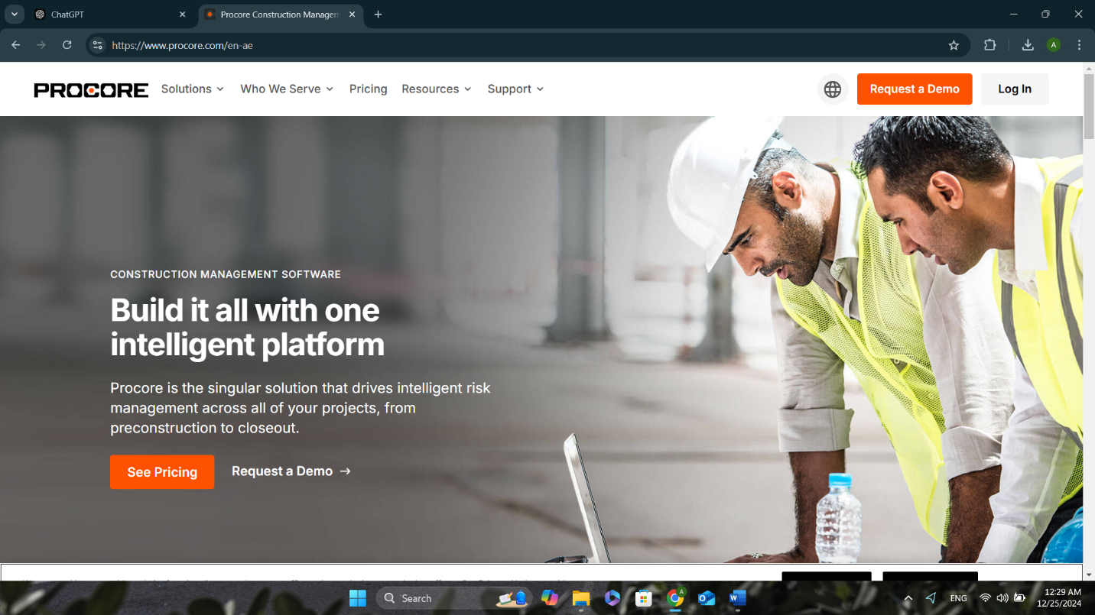

Photo of Procore website

**1.9.3 Builder trend:**

Builder trend is another leading player in the construction management software space, specializing in project scheduling, budgeting, and client communication. It offers a range of tools that allow contractors and project managers to manage construction projects efficiently.

However, Builder trend is often seen as more suitable for smaller to mid-sized construction companies and may lack some advanced features needed by larger firms. **WE-BUILD** provides a more scalable and customizable solution, aimed at improving efficiency across various project sizes while maintaining an intuitive user experience.

Picture of builder trend website

**Opportunities for Improvement and Growth**

The adoption of the proposed system presents significant opportunities for the construction company:

Operational Efficiency: By integrating all project management tools into a single platform, the system will streamline operations and reduce manual effort, leading to higher productivity and efficiency.

Data-Driven Decision Making: The system will provide real-time data, enabling better strategic decisions based on accurate and current information.

Scalability: The system is designed to grow alongside the company, allowing for the addition of more projects, resources, and clients without performance degradation.

Competitive Advantage: Adopting modern technology will differentiate the company from competitors, making it more attractive to potential clients by ensuring faster delivery times, fewer errors, and better overall project outcomes.

Enhanced Client Satisfaction: With improved communication and CRM integration, the company can better meet client expectations, leading to increased customer loyalty and potential referrals.

Risk Reduction: Real-time monitoring of resources, budgets, and timelines will enable early detection of potential risks, allowing for timely interventions and mitigation strategies.

**Proposed System Constraints and Assumptions**

1-Constraints :

Budget Limitations: The system development and implementation must stay within the financial constraints of the company, which may limit certain advanced features.

Timeframe: The system must be delivered within a specified timeline to ensure timely deployment for ongoing projects.

Technical Infrastructure: The system will rely on existing infrastructure, which may not be optimized for cutting-edge technology, resulting in potential performance limitations.

User Adoption: Training and user adoption are essential to the success of the system. Resistance to change among staff may hinder full system utilization.

Data Security and Privacy: The system must comply with legal and industry regulations regarding data privacy and security, especially for client information.

Integration with Existing Tools: The system must integrate smoothly with the company’s existing software tools to avoid operational disruptions.

Assumptions :

Internet Access: It is assumed that all users will have reliable internet access to interact with the cloud-based system.

User Competency: The users are assumed to have a basic level of competency with technology and will receive adequate training.

Accurate Data Input: The effectiveness of the system relies on accurate and timely data input by team members.

Client Collaboration: It is assumed that clients will be willing to interact with the system for communication and feedback.

Stable Financial Condition: The company’s financial condition will remain stable, allowing for system development and implementation without disruption.

**System Stakeholders**

1-Primary Stakeholders:

Project Managers: They will be the main users of the system, overseeing project timelines, budgets, and resources. Their role is critical to ensuring the system’s success.

Clients: As the recipients of the contracted projects, clients will interact with the CRM module and project updates.

Company Executives: They will use the system to monitor high-level project progress, resource utilization, and financial performance.

Team Members (Staff): Project team members will use the system to provide updates, track their tasks, and communicate with other stakeholders.

Suppliers/Subcontractors: They will interact with the communication module to receive updates and share relevant information about the project.

2-Secondary Stakeholders:

IT Support Staff: Responsible for maintaining the system, resolving technical issues, and ensuring its continuous operation.

Training Staff: They will ensure that all users are properly trained to use the system effectively.

2.6 Required Tools

Project Management Software: A tool like Microsoft Project or a custom-built project management tool will be required for tracking progress and timelines.

CRM Software: A Customer Relationship Management system such as Salesforce or a custom CRM module integrated within the project management system.

Cloud Hosting Platform: The system will be hosted on a secure cloud platform, such as AWS or Microsoft Azure, to ensure accessibility and reliability.

Communication Platform: Integration with communication tools like Slack or Microsoft Teams for real-time collaboration.

Database Management System: A robust database management system (MySQL, PostgreSQL) to store project and client data.

**Development Approach**

The development of the system will follow an Agile methodology to ensure flexibility and adaptability during the development process. Key stages include:

Requirement Gathering: Involve all stakeholders to gather detailed requirements and ensure alignment with business objectives.

System Design: Create detailed designs for the user interface, database architecture, and system integration.

Development: Break the development into multiple sprints, each focusing on a specific feature (, project tracking, resource management).

Testing: Perform unit testing and user acceptance testing (UAT) after each sprint to ensure functionality and usability.

Deployment: Gradual deployment of the system to avoid disruptions, followed by post-deployment monitoring and support.

User Training: Conduct training sessions for all users to ensure they understand how to use the system effectively.

Ongoing Support and Updates: After deployment, the development team will provide continuous support and future updates based on feedback.

**1.10 SWOT Analysis**

**1.11 Business Model Canvas**

**1.12 Revenue Model**

**1.12.1 Commission-Based Model**

The commission-based model involves earning money by facilitating transactions between parties and taking a percentage or fixed fee for each deal. WE-BUILD uses this way:

* Flat Rate Commission: A fixed fee is charged for services provided, such as helping companies secure subcontractors or suppliers through the platform. For example, a 5% commission on the value of any subcontractor contract facilitated through the system.

This model also applies to any premium services offered, such as project consultations or exclusive supplier partnerships facilitated through the platform.

# 

# **Chapter 2: Data Collection**

**2.1 Questionnaire**

This questionnaire was distributed among 73 different homeowners in Egypt. And we have got people from different age groups from 21-50 because they are our main target audience.

Question 1 age

Like you see majority of ages are from 21 to 26

Question 3: do you own a property

Question 4: Have you or someone you know hired a construction company before?

**Question 5:** When choosing a construction company, what are the most important factors to you?

question 6: If you had to hire a construction company, what type of services would you need most?

question 7: How often do you like to make renovations or updates to your home?

Question 8: Sustainability Importance: How important are sustainable and eco-friendly materials for your project?

Question 9: Timeline Flexibility: How flexible are you with the project timeline?

**Question 10:** What is your biggest concern when hiring a construction company?

**2.2Interviews**

**Interview 1:**

Purpose of the interview: To get useful information, Confirmation.

Interviewee: **Ahmed Abdallah (CEO Ibuild)**

Interviewer: Youssef Mohamed Samaha

Date: Saturday, December 2nd, 2024

Location: IBUILD Headquarters

question1: What are the biggest problems your company faces in managing projects?

Response1: difference in prices of supplies and mobilization.

2. How do you keep track of project progress and resources now?

Response 2: By using Microsoft project management and everyone achieve their task

3. Are there any common delays or mistakes in your projects?

Response 3: Failure to collect the delayed payments before delivery and how the person managing the project can focus on overlapping tasks.

**About Technology**

Question4: Do you use any software to manage your projects? If yes, does it have any problems?

Response 4: Yes we use project management software’s and we don’t have any problems with it

Question5: Are you willing to try new tools to make work easier?

Response 5: Absolutely, I am always open to exploring new tools that can make work easier and more efficient. As a construction company CEO, my priority is to ensure we deliver high-quality projects on time and within budget

6. What features would you like in a tool to help your work?

Response 6: Software that links accounting with tasks

**About the System Idea**

1. Would real-time updates about project progress be helpful?

Response 7: Real-time updates are invaluable in construction. They enhance communication, improve decision-making, boost client trust through transparency, and help address issues promptly, ensuring projects stay on track.

8. Would it help to have one platform for project tracking, resource management, and client communication?

It will facilitate and speed up the work because it will provide real-time visibility of the tasks.

Question9: Could this kind of system help you finish projects on time and on budget?

Response 9: Yes, a system with real-time updates and continuous client feedback would greatly help finish projects on time and on budget. By identifying issues early, improving communication, and making data-driven decisions, we can minimize delays, manage resources efficiently, and keep costs under control.

**About Clients**

10. How do you stay in touch with clients and get their feedback?

Response 10: We stay in touch with clients through regular progress meetings, emails, and phone updates. For feedback, we conduct surveys, hold post-project reviews, and maintain open communication throughout the project to address concerns and ensure satisfaction.

11. Do you think better client communication would improve their satisfaction?

Response 11: Yes, better client communication is key to improving satisfaction. Keeping clients informed throughout the project, whether through regular updates, addressing concerns promptly, or providing transparency—helps build trust and ensures they feel involved and valued. This leads to a more positive overall experience and enhances client retention.

**About Growth**

12. What makes your company better than others?

Response 12: I want to offer something that stands out in the field (construction in the sports sector).

13. Would having better tools and information help you stay ahead of competitors?

Yes, having better tools and information would definitely help us stay ahead of competitors. By leveraging advanced technologies for real-time updates, project management, and data analysis, we can optimize efficiency, reduce risks, and deliver higher-quality projects faster. Staying innovative and informed enables us to offer superior service, making us more competitive in the market.

**About Using the System**

14. Do you think it will be hard for your team to learn a new system?

Response 14: With training it will be easier

15. Do you need a system that can grow with your company and connect with tools you already use?

Response 15: Yes, a system that can grow with the company and integrate seamlessly with the tools we already use is essential. As the company expands, we need a flexible, scalable solution that adapts to new challenges and integrates with existing processes, ensuring efficiency and minimizing disruptions. This kind of system will support long-term growth while maintaining operational consistency

# **Interview 2:**

# Purpose of the interview: To get useful information, Confirmation.

# Interviewee**: Ahmed Amr Sadek**

# Interviewer: Abdallah Ahmed Abdallah

# Date: Sunday, December 3rd, 2023

# Location: Hayah Sports Academy (HSA)

# Client Interview Questions for Home Construction

## Understanding Their Vision

1. What is your vision for your new home?  
Response: I want a smart home with modern furniture and very strong infrastructure.

2. Do you have specific architectural styles or designs in mind?  
Response: modern design theme

3. What features are most important to you in your home?  
Response :ground ,rainfall shower, heated floors

## Budget and Timeline

1. What is your budget for the project?  
Response: I don’t have a specific budget but I want to spend good on infrastructure.

2. Do you have a specific deadline for completing the construction?  
Response: average 4 months

3. Are there any financial constraints or funding sources we should consider?  
Response: no cash only

## Location and Land

1. Do you already have land for the construction, or are you still looking for a plot?  
Response:yes I have land

2. Is there anything specific about the location that is important to you?  
Response: yes I am looking for my view in front of a clubhouse so I need a really good balcony for the view

## Functional Needs

1. How many bedrooms and bathrooms do you need?  
Response:1 master bedroom, 1 bedroom ,and 1 bathroom

2. Are there specific requirements for the kitchen or living areas?  
Response: yes an American kitchen

3. Do you require any special-purpose rooms? (E.g., gym, home theater, library)  
Response:gym room in the basement

## Sustainability and Materials

1. How important is sustainability to you? (Eco-friendly materials, energy-efficient designs)  
Response: smart home

2. Are there specific materials you prefer or want to avoid?  
Response: high end materials only

## Aesthetics and Finishes

1. Do you have preferences for interior finishes, such as flooring, lighting, or wall colors?  
Response: grey and black palate

2. What kind of exterior finish do you envision? (Brick, stone, stucco, etc.)  
Response: bricks

## Lifestyle Considerations

1. Will the home need to accommodate any special requirements? (E.g., accessibility for elderly or disabled family members)  
Response: no

2. Are outdoor spaces, such as a garden, pool, or patio, important to you?  
Response: yes I want pool

## Communication and Updates

1. How involved do you want to be in the construction process? (Regular updates, site visits)  
Response: yes ofc I need to know everything

2. What is your preferred method of communication during the project? (Email, phone, in-person meetings)  
Response: email and phone

## Concerns and Priorities

1. What concerns or challenges do you foresee with this project?  
Response: time is key

2. What are your top priorities during the construction process? (Quality, speed, staying within budget)  
Response: quality and high end products

**Chapter 3: Feasibility Study**

Feasibility refers to the practicality and likelihood of achieving a specific goal or completing a project under existing constraints. It assesses whether something can be accomplished effectively, considering resources, technology, time, and effort.

Key Aspects of Feasibility

* Capability: Can it be achieved with the available technology, skills, and resources?
* Viability: Is it practical in terms of time, cost, and effort?
* Likelihood of Success: How probable is achieving the desired outcome?
* Practicality: Is it realistic and achievable in the current context?

Feasibility involves evaluating various factors, such as:

* Technical Feasibility: Availability of necessary technology, tools, and expertise.
* Economic Feasibility: Cost-effectiveness and profitability.
* Legal and Regulatory Feasibility: Does it comply with all relevant laws and regulations?
* Social and Environmental Feasibility: Will it have positive social and environmental impacts?
* While formal feasibility studies are common for significant projects, the principles also apply to smaller decisions, guiding informed choices about pursuing ideas.

Focus on Technical Feasibility

For WE-BUILD, the study emphasizes technical feasibility, divided into:

* Qualitative Feasibility: Assessing the skills, tools, and technologies required to achieve the project goals.
* Quantitative Feasibility: Measuring performance, resource availability, and technical scalability.

This analysis ensures WE-BUILD is both practical and achievable, leveraging the best tools and practices to address contracting industry challenges.

## 

## **3.1 Technical Feasibility**

**3.1.1 Qualitative Feasibility**

|  |  |  |  |  |  |  |  |  |  |
| --- | --- | --- | --- | --- | --- | --- | --- | --- | --- |
| Use Case Points Worksheet | | | | |  |  |  |  | |
| 1. Calculate the UUCW. | | | | |  |  |  |  |  |
| Use case number | # of main scenarios | # of extensions | Total transaction | Use case weight |  |  |  |  |  |
| 1 | 1 | 1 | 2 | 5 |  |  |  |  |  |
| 2 | 1 | 2 | 3 | 5 |  |  |  |  |  |
| 3 | 1 | 3 | 4 | 10 |  |  |  |  |  |
| 4 | 1 | 4 | 5 | 10 |  |  |  |  |  |
| 5 | 1 | 4 | 5 | 10 |  |  |  |  |  |
| 6 | 1 | 2 | 3 | 5 |  |  |  |  |  |
| 7 | 1 | 1 | 2 | 5 |  |  |  |  |  |
| 8 | 1 | 0 | 1 | 5 |  |  |  |  |  |
| Total unadjusted use case weight (UUCW) | | | | 55 |  |  |  |  |  |
|  |  |  |  |  |  |  |  |  |  |
| 2. Calculate the UAW. | | | | |  |  |  |  |  |
| Actor type | # of actors | Actor weight | Total actor weight |  |  |  |  |  |  |
| Simple | 0 | 1 | 0 |  |  |  |  |  |  |
| Average | 4 | 2 | 8 |  |  |  |  |  |  |
| Complex | 4 | 3 | 12 |  |  |  |  |  |  |
| Total unadjusted actor weight (UAW) | | | 20 |  |  |  |  |  |  |
|  |  |  |  |  |  |  |  |  |  |
| 3. Calculate the UUCP. | | | | |  |  |  |  |  |
| UUCW | UAW | UUCP |  |  |  |  |  |  |  |
| 55 | 20 | 75 |  |  |  |  |  |  |  |
|  |  |  |  |  |  |  |  |  |  |
| 4. Calculate the TFactor and the TCF. | | | | |  |  |  |  |  |
| Factor ID | Description | Weight | Rating (0-5) | Value (Weight x Rating) |  |  |  |  |  |
| T1 | Distributed system | 2 | 2.5 | 5 |  |  |  |  |  |
| T2 | Performance objectives | 1 | 2.5 | 2.5 |  |  |  |  |  |
| T3 | End user efficiency | 1 | 2.5 | 2.5 |  |  |  |  |  |
| T4 | Complex processing | 1 | 2.5 | 2.5 |  |  |  |  |  |
| T5 | Reusability | 1 | 2.5 | 2.5 |  |  |  |  |  |
| T6 | Easy to install | 0.5 | 2.5 | 1.25 |  |  |  |  |  |
| T7 | Usability | 0.5 | 2.5 | 1.25 |  |  |  |  |  |
| T8 | Portability | 2 | 2.5 | 5 |  |  |  |  |  |
| T9 | Modifiability | 1 | 2.5 | 2.5 |  |  |  |  |  |
| T10 | Concurrency | 1 | 2.5 | 2.5 |  |  |  |  |  |
| T11 | Security | 1 | 2.5 | 2.5 |  |  |  |  |  |
| T12 | Access for third parties | 1 | 2.5 | 2.5 |  |  |  |  |  |
| T13 | Training needs | 1 | 2.5 | 2.5 |  |  |  |  |  |
|  |  |  | Total technical factor (TFactor) | 35 |  |  |  |  |  |
|  |  |  | TCF | 0.95 |  |  |  |  |  |
|  |  |  |  |  |  |  |  |  |  |
| 5. Calculate the EFactor and the EF. | | | | |  |  |  |  |  |
| Factor ID | Description | Weight | Rating (0-5) | Value (Weight x Rating) |  |  |  |  |  |
| E1 | Familiarity with the development process | 1.5 | 2.5 | 3.75 |  |  |  |  |  |
| E2 | Application domain experience | 0.5 | 2.5 | 1.25 |  |  |  |  |  |
| E3 | Development methodology experience | 1 | 2.5 | 2.5 |  |  |  |  |  |
| E4 | Analyst capability | 0.5 | 2.5 | 1.25 |  |  |  |  |  |
| E5 | Motivation | 1 | 2.5 | 2.5 |  |  |  |  |  |
| E6 | Stability of requirements | 2 | 2.5 | 5 |  |  |  |  |  |
| E7 | Use of part-time staff | -1 | 2.5 | -2.5 |  |  |  |  |  |
| E8 | Difficulty of programming language | -1 | 2.5 | -2.5 |  |  |  |  |  |
|  |  |  | Total environment factor (EFactor) | 11.25 |  |  |  |  |  |
|  |  |  | EF | 1.0625 |  |  |  |  |  |
|  |  |  |  |  |  |  |  |  |  |
| 6. Calculate the total number of use case points, or UCP. | | | | |  |  |  |  |  |
| 75.703125 | | | | |  |  |  |  |  |
| 7. Estimate the total effort. | | | | |  |  |  |  |  |
| 45421.875 | | | | |  |  |  |  |  |

**6.Calculate the total number of use case points or ucp**

**=75.703125 hours**

**7.estimate total effort.**

**=45421.875**

**What assumptions did you make**

**To build this system it needs a total of 75.703725 working hours which will cost 600 pounds per hour**

**With total of 45421.875**

**Quantitative feasibility**

**1)** Software

|  |  |
| --- | --- |
| **item** | **price** |
| **Microsoft office 365** | **350EGP/month** |
| **Figma** | **750 EGP/month** |
| **Visual paradigm subscription** | **950 EGP/month** |
| **Oracle database** | **5425 EGP/month** |
| **total** | **7475 EGP/month** |

**Total technical cost=45427.875+7475=52896.875**

**Expenses Cost = 250,000 EGP**

**Expenses Cost includes ads, banners, and marketing expenses.**

**Total cost=52896.875+250,000=302,896.875**

**3.2 Economic Feasibility**

Fixed cost 302,896.875

Average cost per villa,apartment,office=(10+2+1.5)/3=2.8M

Average commission cost per project 5% of the average project cost(2.8M) =140,000EGP

The commission will be divided into installments on average 6 months per project

Average one project installment per month=140,000/6=23,000EGP

Starting number of projects 1

Growth rate user double each month

Break even 4 months

| Month | Project | Monthly Revenue (EGP) | Cumulative Revenue (EGP) |
| --- | --- | --- | --- |
| 1 | 1 | 23,000 | 23,000 |
| 2 | 3 | 69,000 | 92,000 |
| 3 | 5 | 115,000 | 207,000 |
| 4 | 6 | 138,000 | 345,000 |
| 5 | 7 | 161,000 | 506,000 |
| 6 | 8 | 184,000 | 690,000 |

**3.2.1 Break Even Chart**

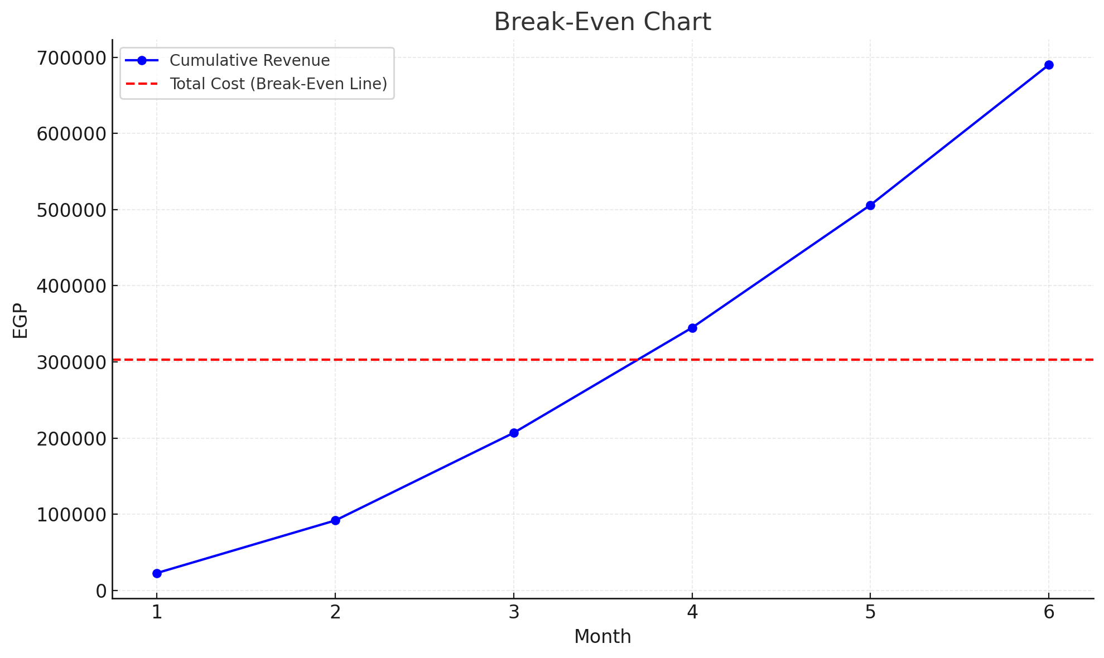

**This break even chart is based on prediction and an optimistic scenario of having 1st month 1 project and every month the number of projects is increased in addition to our revenue models we will reach break even point after 4 months**

**3.3 Legal Feasibility**

**All of our work is legal 100%.**

# 

# **Chapter 4: Project Management**

## **4.1 Gantt Chart**

# **Chapter 5: Data Modeling**

**5.1 Entity Relation Diagram (ERD)**

**5.2 Data Flow Diagram (DFD) LEVEL 0**

**5.3 Unified Modeling Language (UML)**

**What is UML?**

**Unified Modeling Language (UML) is a standardized visual language used to model software systems and other complex processes. It provides a universal framework to:**

* **Visualize, specify, construct, and document system architecture, components, and behavior.**
* **Facilitate understanding across various programming languages due to its language-independent nature.**

**Key Features**

* **Diagrams: UML includes several diagram types, each tailored to represent different system aspects:**
  1. **Use Case Diagrams: Depict system functionality from a user's perspective.**
  2. **Activity Diagrams: Represent the flow of actions and activities within a system.**
  3. **Sequence Diagrams: Show interactions between objects over time.**
  4. **Class Diagrams: Illustrate the structure of classes and their relationships.**
  5. **Object Diagrams: Provide a snapshot of instances of a class diagram.**
  6. **Communication Diagrams: Detail the interactions between system components.**

**Benefits**

* **Improved Communication: Offers a shared visual language for developers, architects, analysts, and stakeholders.**
* **Enhanced Understanding: Simplifies complex systems by providing clear visuals.**
* **Better Design: Supports exploration and validation of various design options.**
* **Effective Documentation: Ensures concise and consistent documentation of system architecture and behavior.**
* **Standardization: Encourages consistency and reusability across projects and organizations.**

**Common Uses**

* **Software Development: Modeling software systems, from requirements gathering to implementation.**
* **Business Modeling: Representing business processes, workflows, and organizational structures.**
* **Systems Engineering: Designing complex systems in domains like healthcare, manufacturing, and finance.**

**UML serves as a critical tool for WE-BUILD, enabling the visualization and efficient design of its project management system.**

### 

### **5.3.1 Use Case Diagrams.**

Manage user use case

**Manage project use case**

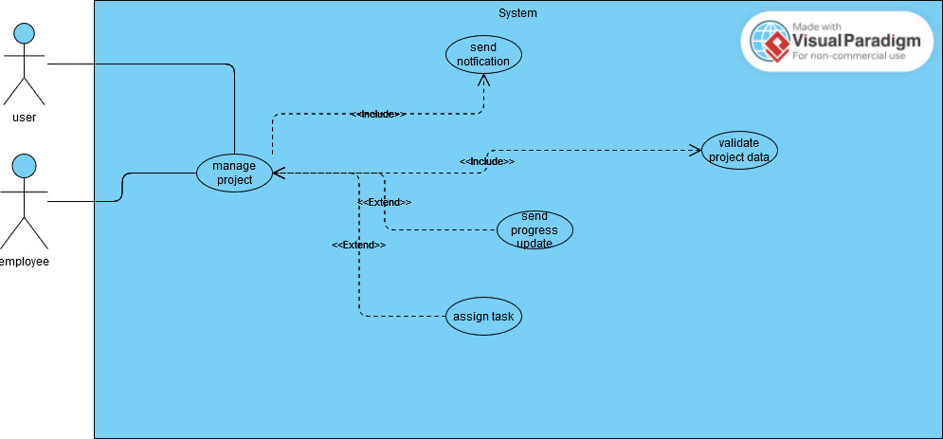

**Manage task use case**

**Manage order use case**

**Manage inventory use case**

**Manage suppliers use case**

**Manage payroll use case**

**Manage feedback use case**

**Use case scenario**

| **Use case number** | **2** |
| --- | --- |
| **Use case name** | **Manage Project** |
| **Short Definition** | **This use case allows clients and employees to manage project-related tasks and data. It includes validating project data, sending notifications, and updating progress.** |
| **Actors** | **Client, Employee** |
| **Main scenario outline** | **1. The client or employee initiates project management. 2. The system validates project data. 3. The system sends notifications regarding project updates. 4. Progress updates are sent during the project lifecycle. 5. Tasks can be assigned to different clients/employees.** |
| **Secondary scenarios** | **1. If project data validation fails, the system prompts for correction and resubmission. 2. If task assignment is unsuccessful, the system notifies the client or employee to retry. 3. If notification delivery fails, a retry mechanism is initiated.** |
| **Numbers of actors** | **2 (Client, Employee)** |

| **Use case number** | **1** |
| --- | --- |
| **Use case name** | **Manage User Data** |
| **Short Definition** | **This use case allows users to manage their account by signing up, confirming accounts, resetting passwords, and signing in. The system validates and revalidates data, sends activation links, and handles errors.** |
| **Actors** | **User** |
| **Main scenario outline** | **1. The user enters account details. 2. The system sends an activation link. 3. The user clicks the activation link to confirm the account. 4. The user enters credentials to sign in. 5. The system validates the credentials and grants access. 6. Users can reset passwords by sending another activation link if needed.** |
| **Secondary scenarios** | **1. If data validation fails, the system prompts to re-enter data. 2. If the activation link is not received, the user can request another link. 3. Errors during revalidation trigger error messages and retries.** |
| **Numbers of actors** | **1 (User)** |

| **Use case number** | **3** |
| --- | --- |
| **Use case name** | **Manage Tasks** |
| **Short Definition** | **This use case allows employees to manage tasks by assigning, validating, and tracking task progress. Notifications are sent for assignments and delays.** |
| **Actors** | **Employee** |
| **Main scenario outline** | **1. The employee manages tasks by initiating task assignment. 2. The system validates task data and task assignments. 3. Task assignments are notified to employees. 4. The employee tracks task progress. 5. The system validates task progress and notifies of any delays.** |
| **Secondary scenarios** | **1. If task data validation fails, the system prompts re-entry. 2. If an employee does not receive a task assignment, the system resends the notification. 3. If a delay is detected in task progress, an automatic task delay notification is sent.** |
| **Numbers of actors** | **1 (Employee)** |

| **Use Case Number** | **4** |
| --- | --- |
| **Use Case Name** | **Manage Order** |
| **Short Definition** | **This use case handles the entire process of managing client orders, from placement to fulfillment or cancellation.** |
| **Actors** | **Client, Employee, Supplier** |
| **Main Scenario Outline** | **1. Client places an order.2. Employee validates the order.3. Inventory availability is checked.4. Payment is approved and invoice generated.5. Supplier fulfills the order, and order details are updated.** |
| **Secondary Scenarios** | **1. If inventory is unavailable, the employee requests the supplier.2. Clients can cancel orders before fulfillment.3. Notification is sent to the supplier about order status changes.** |
| **Number of Actors** | **3** |

| **Use Case Number** | **5** |
| --- | --- |
| **Use Case Name** | **Manage Inventory** |
| **Short Definition** | **This use case focuses on tracking, managing, and maintaining inventory data, including notifying for low stock or damages.** |
| **Actors** | **Warehouse Manager** |
| **Main Scenario Outline** | **1. Warehouse manager manages inventory items and transactions.2. Inventory data is validated.3. Generate inventory reports for updates.4. Track inventory usage to ensure accurate records.** |
| **Secondary Scenarios** | **1. Notify low stock when thresholds are reached.2. Notify damages in inventory.3. Generate reports for inventory adjustments.** |
| **Number of Actors** | **1** |

| **Use Case Number** | **6** |
| --- | --- |
| **Use Case Name** | **Manage Suppliers** |
| **Short Definition** | **This use case handles supplier-related tasks, including adding supplier information, placing and tracking orders, and managing deliveries.** |
| **Actors** | **Warehouse Manager, Supplier** |
| **Main Scenario Outline** | **1. Warehouse manager verifies supplier information.2. Supplier order is placed.3. Warehouse manager tracks supplier orders and receives deliveries.4. Supplier report is generated and validated.** |
| **Secondary Scenarios** | **1. Notify delays in supplier deliveries.2. Delete outdated or invalid supplier information.3. Add supplier details for new suppliers.** |
| **Number of Actors** | **2** |

| **Use case number** | **7** |
| --- | --- |
| **Use case name** | **Manage Payroll** |
| **Short Definition** | **This use case enables the HR Manager and Bank to calculate salaries, validate payroll data, process payments, and generate payroll reports.** |
| **Actors** | **HR Manager, Bank** |
| **Main scenario outline** | **1. HR Manager calculates employee salaries.2. The payroll data is validated.3. Payroll reports are generated.4. Bank processes salary payments.5. Payment files are generated.6. Payment confirmations are notified.** |
| **Secondary scenarios** | **1. If payroll data validation fails, the system prompts the HR Manager to correct the data.2. If payment processing fails, the Bank is notified for troubleshooting.** |
| **Numbers of actors** | **2** |

| **Use case number** | **8** |
| --- | --- |
| **Use case name** | **Manage Feedback** |
| **Short Definition** | **This use case allows users to write, review, and submit feedback, as well as give ratings for services.** |
| **Actors** | **User** |
| **Main scenario outline** | **1. User writes feedback.2. User reviews the written feedback.3. User submits feedback.4. User gives a rating to the service.** |
| **Secondary scenarios** | **1. If feedback review is skipped, the system prompts the user to verify the content.2. If the rating is not provided, the system alerts the user before submission.** |
| **Numbers of actors** | **1** |

### **5.3.3 Activity diagrams**

### **Manage user activity diagram:**

**Manage project activity**

**Manage task activity**

**Manage order activity**

**Manage inventory activity**

**Manage supplier activity**

**Manage payroll activity**

**Manage feedback activity**

**3.5.4 Sequence Diagrams**

**1)user**

**2)project**

**3)task**

**4)order**

**5)inventory**

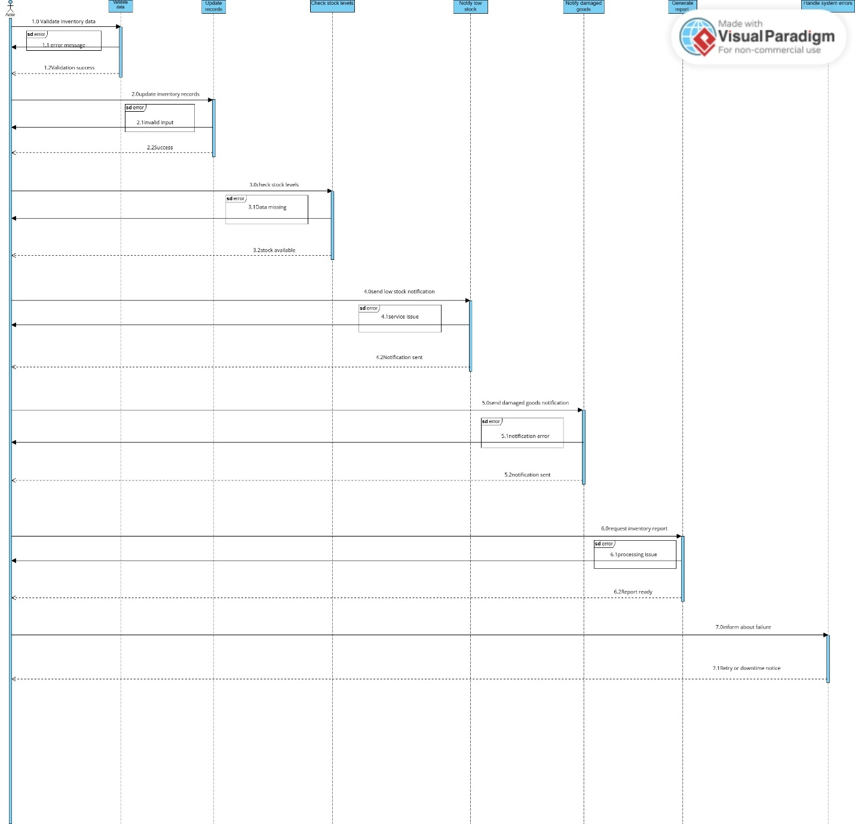

**6)supplier**

**7)payroll**

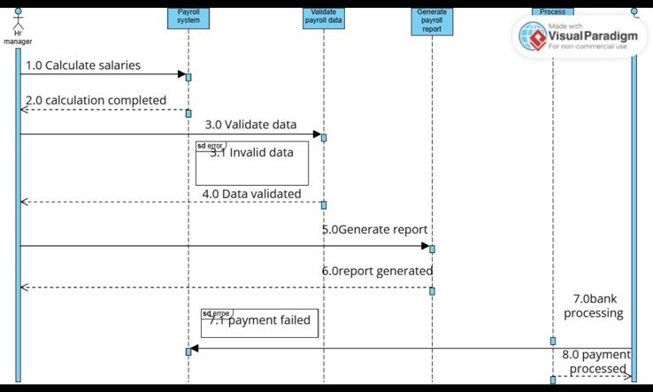

**8)feedback**

**5.3.5 Class Diagram**

### **5.3.6 Object Diagram**

### **5.3.7 Communication Diagrams**

Manage inventory communication diagram

**Manage order ccommunication diagram**

**Manage user communication diagram**

**Manage task communication diagram**

# **Chapter 6: Data Definition Form**

**Supplier**

|  |  |
| --- | --- |
| **Attribute** | **Description** |
| **Supplier_ID** | **A unique identifier for each supplier.** |
| **Name** | **The name of the supplier.** |
| **Contact** | **The supplier's primary contact information (e.g., phone, email).** |
| **Location** | **The physical address of the supplier, including city, district, and street.** |

**Material**

|  |  |
| --- | --- |
| **Attribute** | **Description** |
| **Material_ID** | **A unique identifier for each material.** |
| **Name** | **The name of the material.** |
| **Supplier_ID** | **A foreign key linking the material to a supplier.** |
| **Cost** | **The cost per unit of the material.** |

**Warehouse**

|  |  |
| --- | --- |
| **Attribute** | **Description** |
| **Warehouse_ID** | **A unique identifier for each warehouse.** |
| **Location** | **The physical location of the warehouse, including city, district, and street.** |
| **Storage_Capacity** | **The maximum capacity of the warehouse for storing materials.** |

**Inventory**

|  |  |
| --- | --- |
| **Attribute** | **Description** |
| **Inventory_ID** | **A unique identifier for each inventory record.** |
| **Material_ID** | **A foreign key linking to the Material entity.** |
| **Quantity** | **The number of units of the material in the warehouse.** |
| **Warehouse_Location** | **A foreign key linking to the Warehouse entity.** |

**Equipment**

|  |  |
| --- | --- |
| **Attribute** | **Description** |
| **Equipment_ID** | **A unique identifier for each piece of equipment.** |
| **Name** | **The name of the equipment.** |
| **Purchase_Date** | **The date the equipment was purchased.** |
| **Assigned_Project_ID** | **A foreign key linking the equipment to the project it is used for.** |
| **Cost** | **The purchase cost of the equipment.** |
|  |  |

**Project**

|  |  |
| --- | --- |
| **Attribute** | **Description** |
| **Project_ID** | **A unique identifier for each project.** |
| **Name** | **The name of the project.** |
| **Start_Date** | **The date the project starts.** |
| **End_Date** | **The date the project ends.** |
| **Budget** | **The allocated budget for the project.** |
| **Client_ID** | **A foreign key linking the project to a client.** |
| **Manager_ID** | **A foreign key linking the project to the manager (employee).** |

**Task**

|  |  |
| --- | --- |
| **Attribute** | **Description** |
| **Task_ID** | **A unique identifier for each task.** |
| **Name** | **The name of the task.** |
| **Start_Date** | **The start date of the task.** |
| **End_Date** | **The end date of the task.** |
| **Status** | **The current status of the task (e.g., pending, in progress, completed).** |
| **Assigned_Employee_ID** | **A foreign key linking the task to the assigned employee.** |
| **Project_ID** | **A foreign key linking the task to the project.** |

**Client**

|  |  |
| --- | --- |
| **Attribute** | **Description** |
| **Client_ID** | **A unique identifier for each client.** |
| **Name** | **The name of the client or client organization.** |
| **Address** | **The physical address of the client, including city, district, and street.** |
| **Contact** | **The client's contact information.** |

**Employee**

|  |  |
| --- | --- |
| **Attribute** | **Description** |
| **Employee_ID** | **A unique identifier for each employee.** |
| **Name** | **The full name of the employee.** |
| **Salary** | **The employee's salary.** |
| **Department_ID** | **A foreign key linking the employee to their department.** |
| **Contact** | **The employee's contact information.** |

**Department**

|  |  |
| --- | --- |
| **Attribute** | **Description** |
| **Department_ID** | **A unique identifier for each department.** |
| **Name** | **The name of the department.** |
| **Location** | **The location of the department.** |
| **Manager_ID** | **A foreign key linking to the employee managing the department.** |

**Payroll**

|  |  |
| --- | --- |
| **Attribute** | **Description** |
| **Payroll_ID** | **A unique identifier for each payroll record.** |
| **Employee_ID** | **A foreign key linking the payroll record to an employee.** |
| **Salary** | **The employee's base salary.** |
| **Deductions** | **Any deductions from the salary.** |
| **Total_Payments** | **The final amount paid to the employee after deductions.** |
| **Date** | **The date of payroll processing.** |

**Order**

|  |  |
| --- | --- |
| **Attribute** | **Description** |
| **Order_ID** | **A unique identifier for each order.** |
| **Order_Date** | **The date the order was placed.** |
| **Client_ID** | **A foreign key linking the order to a client.** |
| **Project_ID** | **A foreign key linking the order to a project.** |
|  |  |

**Chapter 7: Prototype**

